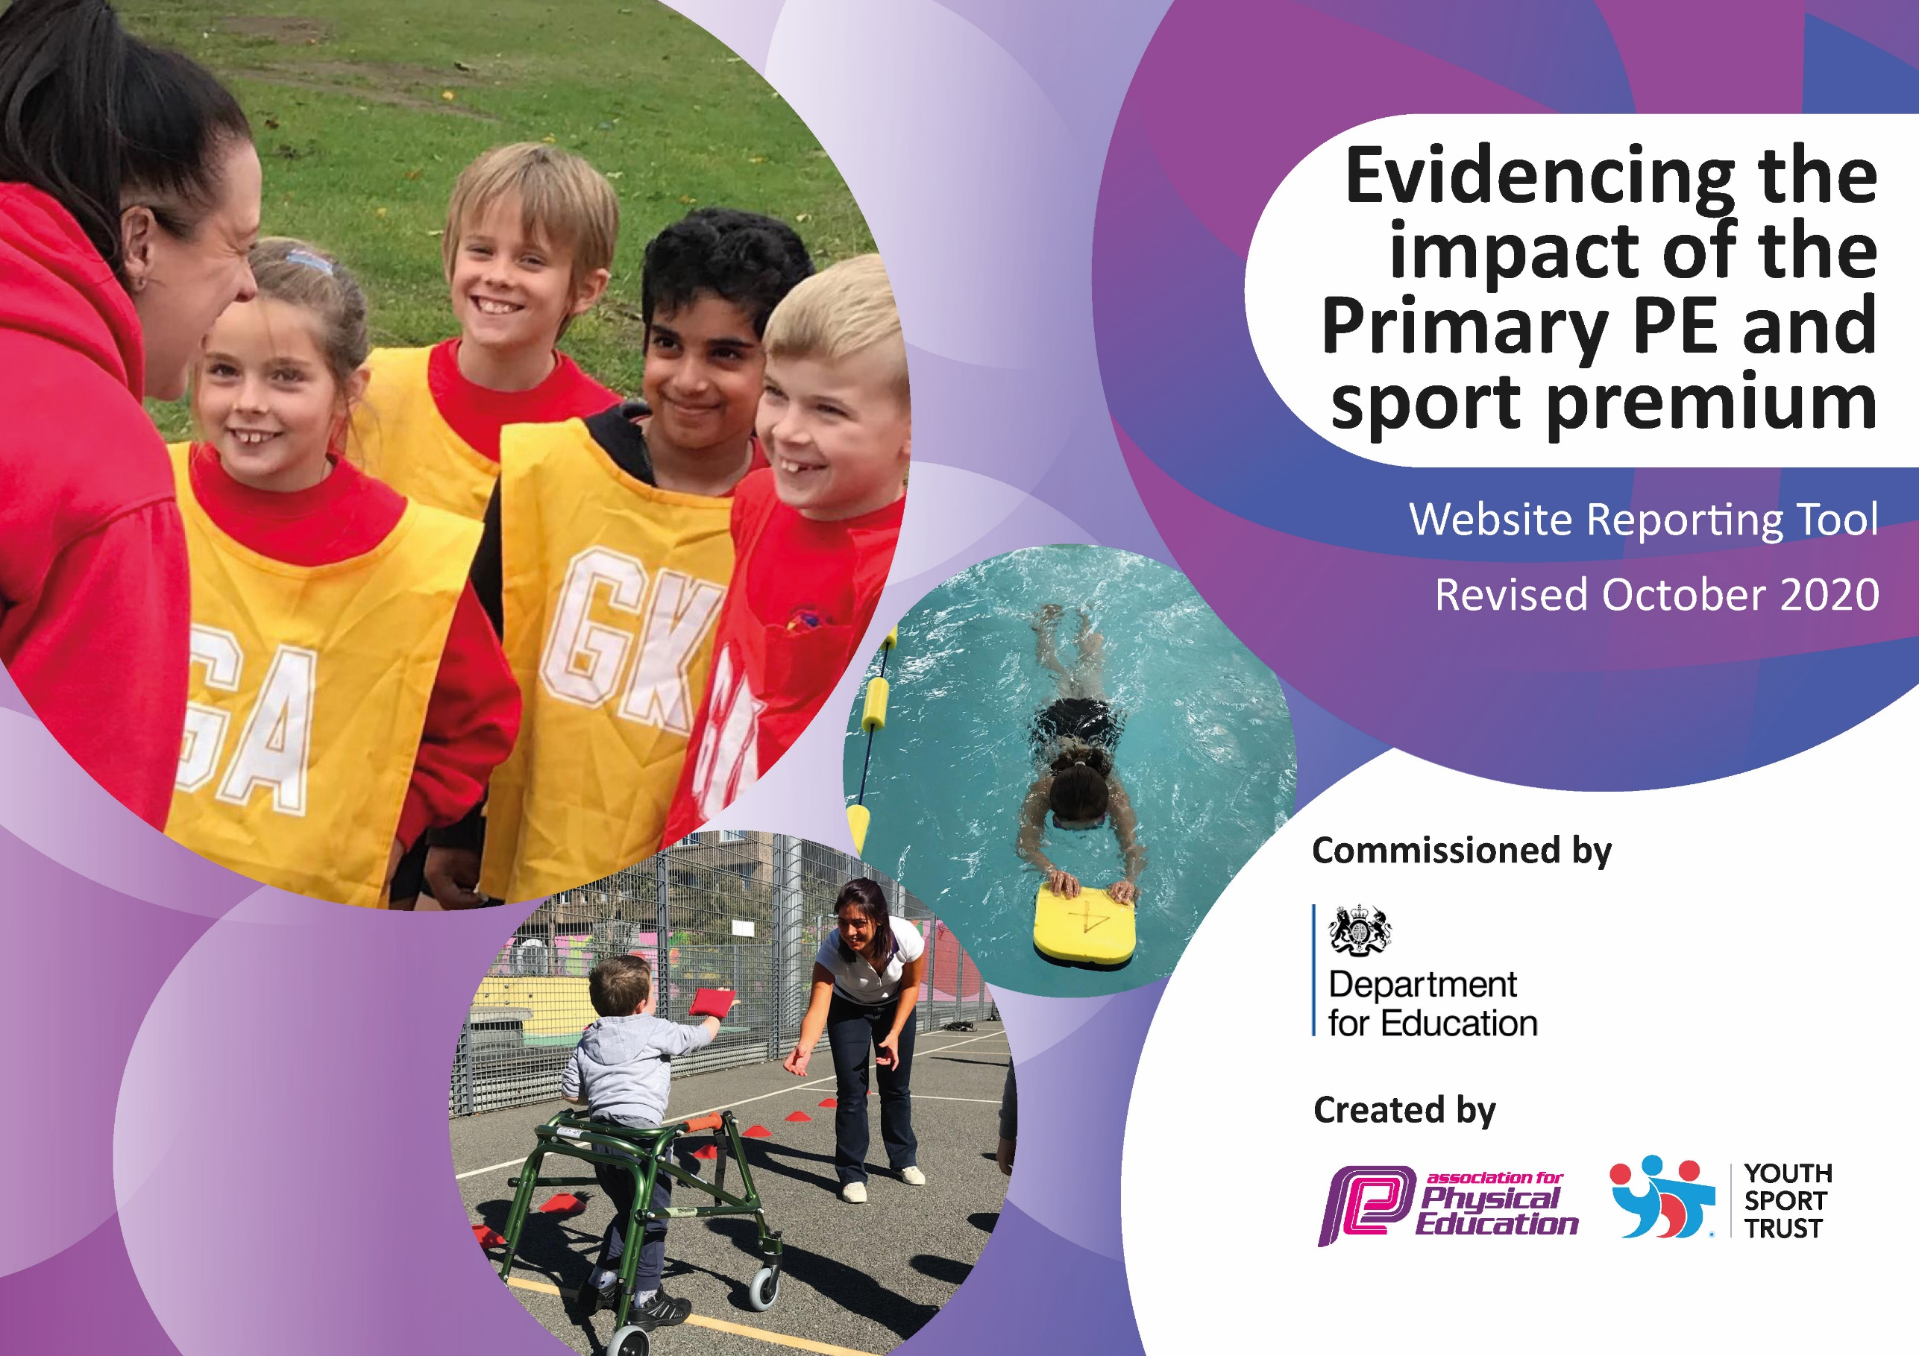

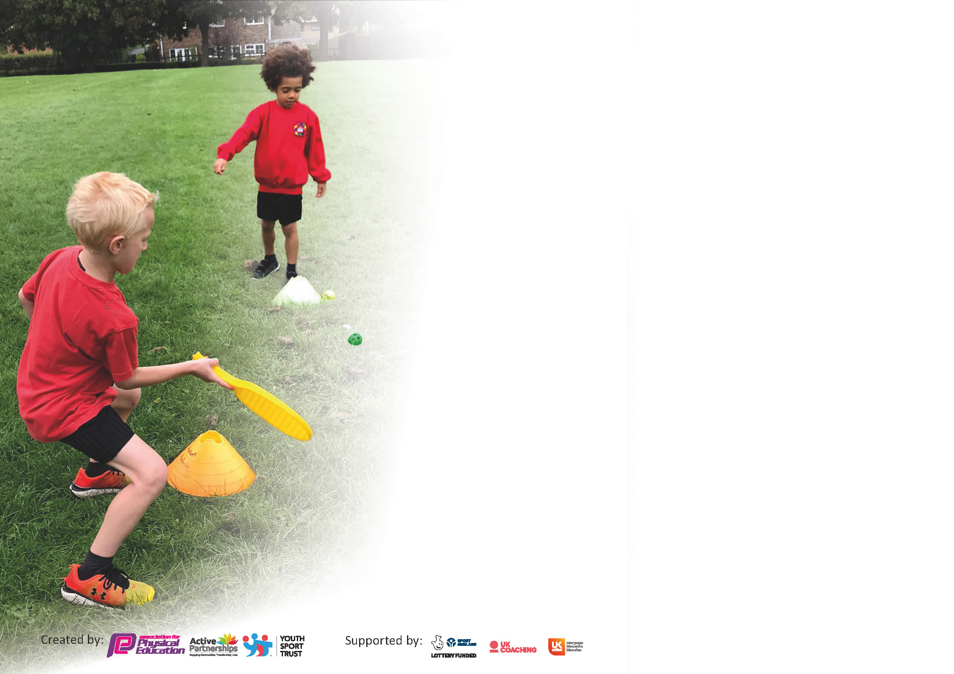

It is important that your grant is used effectively and based on school need. The Education Inspection Framework (Ofsted 2019 p64) makes clear there will be a focus on **‘whether leaders and those responsible for governors all understand their respective roles and perform these in a way that enhances the effectiveness of the school’**.

Under the Quality of Education criteria (p41) inspectors consider the extent to which schools can articulate their curriculum (INTENT), construct their curriculum (IMPLEMENTATION) and demonstrate the outcomes which result (IMPACT).

To assist schools with common transferable language this template has been developed to utilise the same three headings which should make your plans easily transferable between working documents.

Schools must use the funding to make **additional and sustainable** improvements to the quality of Physical Education, School Sport and Physical Activity (PESSPA) they offer. This means that you should use

the Primary PE and sport premium to:

* Develop or add to the PESSPA activities that your school already offer
* Build capacity and capability within the school to ensure that improvements made now will benefit pupils joining the school in future years

Please visit gov.uk for the revised DfE guidance including the 5 key indicators across which schools should demonstrate an improvement. This document will help you to review your

provision and to report your spend. DfE encourages schools to use this template as an effective way of meeting the reporting requirements of the Primary PE and sport premium.

We recommend you start by reflecting on the impact of current provision and reviewing the previous spend.

Schools are required to publish details of how they spend this funding as well as on the impact it has on pupils’ PE and sport participation and attainment by the end of the summer term or by **31st July 2021** at the latest.

# ** In the case of any under-spend from 2019/20 which has been carried over this must be used and published by 31st March 2021.

We recommend regularly updating the table and publishing it on your website throughout the year. This evidences your ongoing self-evaluation of how you are using the funding to secure maximum, sustainable impact. Final copy must

be posted on your website by the end of the academic year and no later than the 31st July 2021. To see an example of how to complete the table please click HERE.

Created by: Supported by:

Please note: Although there has been considerable disruption in 2020 it is important that you publish details on your website of how you spend the funding - this is a legal requirement**. Cromwell**

Support for review and reflection - considering the 5 key indicators from DfE, what development needs are a priority for your setting and your pupils now and why? Use the space below to reflect on previous spend and key achievements and areas for development.

N.B. In this section you should refer to any adjustments you might have made due to Covid-19 and how these will influence further improvement.

|  |  |
| --- | --- |
| Key achievements to date : | Areas for further improvement and baseline evidence of need: |
| * Online gymnastics and yoga sessions delivered by specialist coaches during the lockdown (Spring 2021) from Reception to Year 6 * Sports equipment for pupils to use during break times * CPD in PE for all staff through the support of specialist coaches * All Year 5 pupils took part in Bikeability- Level 1 and 2 * Year 3 pupils and teachers took part in the Aston Villa 10-week teacher CPD programme * 100 % of pupils in Year 6 able to perform safe self-rescue in water-based situations * Year 6 took part in an after-school gymnastics club in summer two * Year 3 took part in an after-school dodgeball club in summer two | * Continue to invest in resources for the teaching of PE. Maintain a good level of high-quality equipment whilst broadening the resources so we can offer a wider range of sports * Continue to invest in resources for after school clubs when they return in the new year * Continue staff training and awareness of high-quality PE teaching * Continue to develop active playtimes and purchase of further resources to support this * Increase the number of pupils swimming 25 metres or by the time the y leave Year 6 * Develop inter and intra competition opportunities * Build links with local sports clubs and coaches to encourage continued high take up of sports out of school hours |

Did you carry forward an underspend from 2019-20 academic year into the current academic year? **YES**

If any funding from the academic year 2019/20 has been carried over you MUST complete the following section. Any carried over funding MUST be spent by 31 March 2021.

|  |  |  |  |  |
| --- | --- | --- | --- | --- |
| **Academic Year: September 2020 to March 2021** | **Total fund carried over: £2400.00** | **Date Updated:**  **March 2021** |  | |
| What Key indicator(s) are you going to focus on?  **Key indicator 4:** Broader experience of a range of sports and activities offered to all pupils | | | | Total Carry Over Funding: |
| £2400.00 |
| **Intent** | **Implementation** | | **Impact** |  |
| Your school focus should be clear how you want to impact on your pupils.  Invite in outside agencies to deliver a variety of different sports and activities for the children to participate in. These could be extracurricular clubs/experiences or as part of the curriculum. | Make sure your actions to achieve are linked to your intentions:  Free@last will deliver climbing wall and archery experiences for Year 1 to Year 6.  Yoga and gymnastics sessions (online) for pupils during lockdown from Nursery to Year 6 and dance sessions for pupils in Y2 and Reception in the Summer term 2021. Staff are able to use the recorded sessions for CPD. | Carry over funding allocated:  £1000.00  £1400.00 | Evidence of impact: How can you measure the impact on your pupils; you may have focussed on the difference that PE, SS & PA have made to pupils re-engagement with school. What has changed?:  Pupils will have the opportunity to participate in activities that they may not normally take part in  The yoga sessions were used to support pupil physical and emotional well-being during lockdown (01/21) as well in the Autumn term (11/2020) | Sustainability and suggested next steps and how does this link with the key indicators on which you are focussing this academic year?:  Pupils have access to a broader range of experiences and the chance to form links with local clubs offering those activities.  Yoga sessions have been recorded to allow staff to use them in the future with pupils |

|  |  |
| --- | --- |
| Meeting national curriculum requirements for swimming and water safety.  N.B Complete this section to your best ability. For example you might have practised safe self-rescue techniques on dry land. |  |
| What percentage of your current Year 6 cohort swim competently, confidently and proficiently over a distance of at least 25 metres?  **N.B.** Even though your pupils may swim in another year please report on their attainment on leaving primary school at the end of the summer term 2021. | 30% |
| What percentage of your current Year 6 cohort use a range of strokes effectively [for example, front crawl, backstroke and breaststroke]? | front crawl= 100%  breaststroke = 23% |
| What percentage of your current Year 6 cohort perform safe self-rescue in different water-based situations? | 100% |
| Schools can choose to use the Primary PE and sport premium to provide additional provision for swimming but this must be for activity **over and above** the national curriculum requirements. Have you used it in this way? | No |

**Action Plan and Budget Tracking**

Capture your intended annual spend against the 5 key indicators. Clarify the success criteria and evidence of impact that you intend to measure to evaluate for pupils today and for the future.

|  |  |  |  |  |
| --- | --- | --- | --- | --- |
| **Academic Year:** 2020/21  **Cromwell** | **Total fund allocated:** £17,800 | **Date Updated: March 2021** | |  |
| **Key indicator 1:** The engagement of all pupils in regular physical activity – Chief Medical Officers guidelines recommend that primary school pupils undertake at least 30 minutes of physical activity a day in school | | | | Percentage of total allocation: |
| 45% |
| **Intent** | **Implementation** | | **Impact** |  |
| Your school focus should be clear what you want the pupils to know and be able to do and about  what they need to learn and to  consolidate through practice: | Make sure your actions to achieve are linked to your intentions: | Funding allocated:  £ 8000.00 | Evidence of impact: what do pupils now know and what can they now do? What has changed?: | Sustainability and suggested next steps: |
| Create opportunities for 30 minutes  of physical activity a day in school | Daily physical activity sessions during the school day , Break time and lunchtime  Lunchtime sports coach to deliver sports activities. | £8000.00 | Pupils have access to play equipment during their break times and take part in brain breaks during their lessons  Pupils have access to lunchtime sports activities and equipment which helps them to stay active and contribute to their 30 minutes of physical daily activity.  Feedback from pupils shows they enjoy the lunchtime provision with the coach | Continue to create a range of opportunities throughout the school day to allow pupils to stay active |
| **Key indicator 2:** The profile of PESSPA being raised across the school as a tool for whole school improvement | | | | Percentage of total allocation: |
| 16% |
| **Intent** | **Implementation** | | **Impact** |  |
| Your school focus should be clear what you want the pupils to know and be able to do and about  what they need to learn and to  consolidate through practice: | Make sure your actions to achieve are linked to your intentions: | Funding allocated:  £2800.00 | Evidence of impact: what do pupils now know and what can they now do? What has changed?: | Sustainability and suggested next steps: |
| School staff aware of purpose of Sports premium and uses and communication from PE Lead about CPD and events(PE display board)  Provide appropriate equipment for a variety of sports activities in and out of curriculum hours | Work with King Edwards Schools Sports Partnership (KESSP) and other agencies to create CPD opportunities for staff to work with specialist coaches. Pupils access high quality PE lessons and extra-curricular provision.  Promote benefits of sports and physical activity on mental, physical and emotional well-being.  Order sports equipment for whole school for PE lessons and extra-curricular provision | £2500.00  £300.00 | Specialist sports coaches worked with class teachers to deliver high quality PE in a range of sports.  Online provision and activity ideas for pupils to take part in (Steps to success)  Pupil voice responses show that pupils enjoyed their PE lessons with sports coaches.  Staff and pupils have access to the equipment that they need | Continue partnerships with KESSP as the range of CPD, after school provision and access to competitions are good value for money  Take care of equipment so it lasts longer  Check what equipment is needed and order for the new year |

|  |  |  |  |  |
| --- | --- | --- | --- | --- |
| **Key indicator 3:** Increased confidence, knowledge and skills of all staff in teaching PE and sport | | | | Percentage of total allocation: |
| 2% |
| **Intent** | **Implementation** | | **Impact** |  |
| Your school focus should be clear | Make sure your actions to | Funding | Evidence of impact: what do | Sustainability and suggested |
| what you want the pupils to know | achieve are linked to your | allocated: | pupils now know and what | next steps: |
| and be able to do and about | intentions: |  | can they now do? What has |  |
| what they need to learn and to |  | £300.00 | changed?: |  |
| consolidate through practice: |  |  |  |  |
| Improve staff confidence in teaching PE and other forms of physical activity | Subscribe to the PE HUB which provides staff with the detailed lessons that encourage skill progression.  Arrange staff CPD with KESSP  Yoga sessions for pupils in Autumn term (11/2020) and during lockdown (01/2021). Delivered in school and online- videos used for staff CPD.  Aspire will also be delivering dance for  Year 2 and Reception in Summer term | £300.00  (indicator 2 cost KESSP)  (carry over funding used) | All staff have access to high quality PE planning with differentiation  Staff develop skills and confidence with the area of PE they have been given CPD in (informal feedback)  Staff were able to see the progression in the Yoga/ well-being sessions and learn alongside the pupils  Pupils and staff were able to access physical activity online which helped to promote physical and emotional well-being  (pupil questionnaires) | Continue to support staff with planning and other support including CPD  Continue CPD provision for staff  Complete staff audit in PE to identify training needs |
| **Key indicator 4:** Broader experience of a range of sports and activities offered to all pupils | | | | Percentage of total allocation: |
| 9% |
| **Intent** | **Implementation** | | **Impact** |  |
| Your school focus should be clear | Make sure your actions to | Funding | Evidence of impact: what do | Sustainability and suggested |
| what you want the pupils to know | achieve are linked to your | allocated: | pupils now know and what | next steps: |
| and be able to do and about | intentions: |  | can they now do? What has |  |
| what they need to learn and to |  | £1660.00 | changed?: |  |
| consolidate through practice: |  |  |  |  |
| Additional achievements:  Invite in outside agencies to deliver a variety of different sports and activities for the children to participate in. These could be extracurricular clubs/experiences or as part of the curriculum. | Work with specialist coaches from KESSP for extra-curricular and curriculum time support  Work with Aspire Dance for Yoga sessions and staff CPD virtual-during lockdown and in with Year 2 and Reception after lockdown.  Free@last to deliver Climbing wall and archery sessions.  Warwickshire Cricket club to deliver Cricket sessions  Additional wall climbing activities -summer term  After- school gymnastics with Positive PE- Year 6 -summer term  Bikeability- Year 5- Summer term | (indicator cost KESSP)  (carry over funding)  (carry over funding)  £500.00  £1000.00  £160.00 | Teacher were given curriculum time support from specialist coaches which pupils enjoyed (pupil voice) but no after school clubs due to Covid restrictions  Online Yoga and gymnastics sessions ensure that all pupils had access to high quality PE during the lockdown. Pupils were able to stay active at home  Pupils were given the opportunity to participate in a range of activities. Archery did not take place  Year 6 participated in one after school gymnastics club (register) | Continue to create opportunities for pupil to take part in a range of sports /well being activities through the year.  Start after school sports clubs again, pupil voice showed that the children really wanted them back. |

|  |  |  |  |  |
| --- | --- | --- | --- | --- |
| **Key indicator 5:** Increased participation in competitive sport | | | | Percentage of total allocation: |
| 2% |
| **Intent** | **Implementation** | | **Impact** |  |
| Your school focus should be clear | Make sure your actions to | Funding | Evidence of impact: what do | Sustainability and suggested |
| what you want the pupils to know | achieve are linked to your | allocated: | pupils now know and what | next steps: |
| and be able to do and about | intentions: |  | can they now do? What has |  |
| what they need to learn and to |  | £300.00 | changed?: |  |
| consolidate through practice: |  |  |  |  |
| Provide additional competitive sport opportunities to engage more pupils in competition | Set aside transport costs for participation in school led competitions as possible with School games Challenge and KESSP  Participate in Steps to Success 6 week challenge with KESSP promoting physical, mental and emotional well-being of pupils. | £300.00  KESSP funding | Pupils did not travel due to Covid restrictions.  All year groups took part in intra competition at the end of the summer term. Pupils enjoyed competing against their peers  Feedback from pupils who participated showed that they enjoyed the activities and it helped them to stay active. | Create opportunities for intra and inter competition, as well as personal best  Promote online sports/well-being activities so that pupils can take part during their holidays |

|  |  |
| --- | --- |
| Signed off by | |
| Head Teacher: | R. Darr |
| Date: | July 2021 |
| Subject Leader: | S. Bi |
| Date: | July 2021 |
| Governor: | S.Parveen |
| Date: | July 2021 |

NB: Left over sports premium for 2020-21 is £4740.00 . This money will be carried forward and added to the sports premium spend for 2021-2022