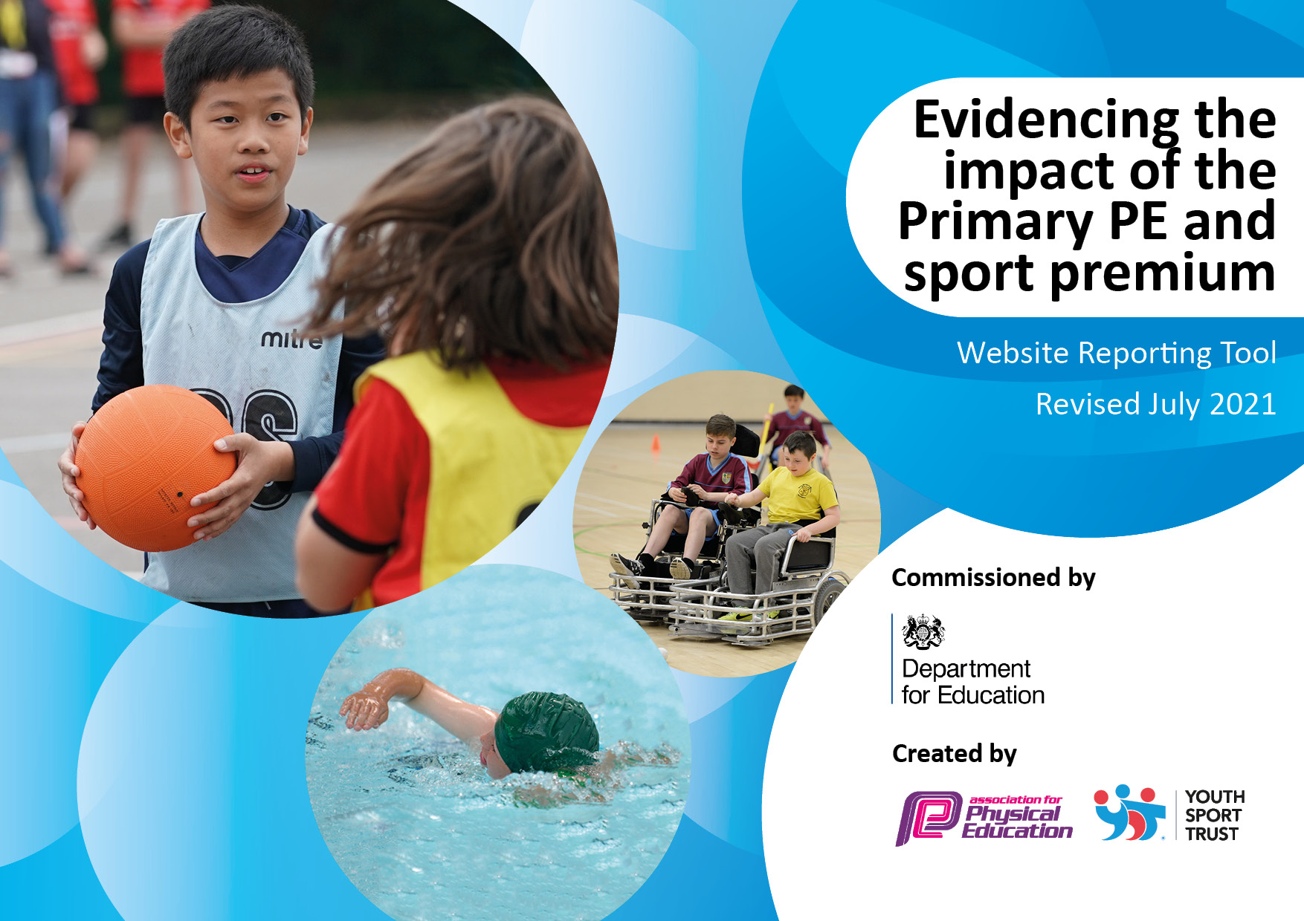

**Website Reporting Tool**

**Revised July 2021**

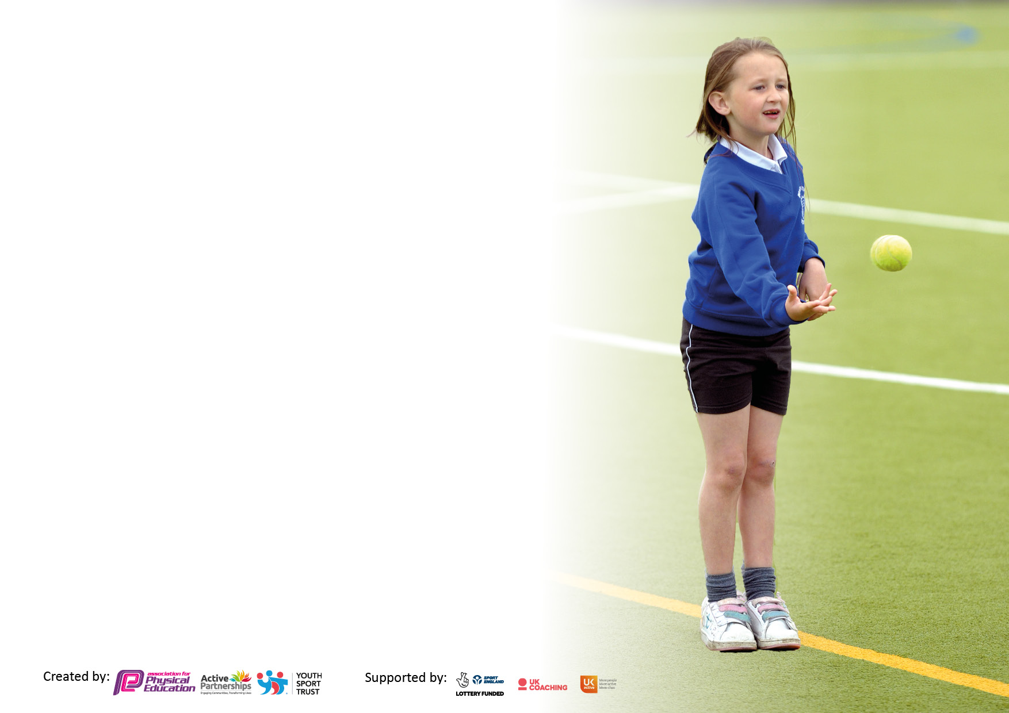

It is important that your grant is used effectively and based on school need. The [Education Inspection Framework](https://assets.publishing.service.gov.uk/government/uploads/system/uploads/attachment_data/file/843108/School_inspection_handbook_-_section_5.pdf) makes clear there will be a focus on **‘whether leaders and those responsible for governors all understand their respective roles and perform these in a way that enhances the effectiveness of the school’**.

Under the [Quality of Education](https://assets.publishing.service.gov.uk/government/uploads/system/uploads/attachment_data/file/843108/School_inspection_handbook_-_section_5.pdf) Ofsted inspectors consider:

**Intent** - Curriculum design, coverage and appropriateness

**Implementation** - Curriculum delivery, Teaching (pedagogy) and Assessment

**Impact** - Attainment and progress

To assist schools with common transferable language this template has been developed to utilise the same three headings which should make your plans easily transferable between working documents.

Schools must use the funding to make **additional and sustainable** improvements to the quality of Physical Education, School Sport and Physical Activity (PESSPA) they offer. This means that you should use the Primary PE and sport premium to:

* Develop or add to the PESSPA activities that your school already offer
* Build capacity and capability within the school to ensure that improvements made now will benefit pupils joining the school in future years
* The Primary PE and sport premium should not be used to fund capital spend projects; the school’s budget should fund these.

Pleasevisit[gov.uk](https://www.gov.uk/guidance/pe-and-sport-premium-for-primary-schools)fortherevisedDfEguidanceincludingthe5keyindicatorsacrosswhichschoolsshoulddemonstrate animprovement.Thisdocumentwillhelpyoutoreviewyourprovisionandtoreportyourspend.DfEencouragesschools to use this template as an effective way of meeting the reporting requirements of the Primary PE and sport premium.

We recommend you start by reflecting on the impact of current provision and reviewing the previous spend.

Schools are required to [publish details](https://www.gov.uk/guidance/what-maintained-schools-must-publish-online#pe-and-sport-premium-for-primary-schools) of how they spend this funding, including any under-spend from 2019/2020, as well as on the impact it has on pupils’ PE and sport participation and attainment. **All funding must be spent by 31st July 2023**

We recommend regularly updating the table and publishing it on your website throughout the year. This evidences your ongoing self-evaluation of how you are using the funding to secure maximum, sustainable impact. Final copy must be posted on your website by the end of the academic year and no later than the 31st July 2023. To see an example of how to complete the table please click [HERE](http://www.afpe.org.uk/physical-education/wp-content/uploads/afPE-Example-Template-Indicator-2018-Final.pdf).



**Details with regard to funding**

Please complete the table below.

|  |  |
| --- | --- |
| Total amount allocated for 2022/23 | £ 17,800.00 |
| Total amount of funding for 2022/23. To be spent and reported on by 31st July 2023 | £17,800.00 |

**Swimming Data**

Please report on your Swimming Data below.

|  |  |
| --- | --- |
| Meeting national curriculum requirements for swimming and water safety.  N.B. Complete this section to your best ability. For example, you might have practised safe self-rescue techniques on dry land which you can then transfer to the pool when school swimming restarts.  **Due to exceptional circumstances priority should be given to ensuring that pupils can perform safe self-rescue even if they do not fully meet the first two requirements of the NC programme of study** |  |
| What percentage of your current Year 6 cohort swim competently, confidently, and proficiently over a distance of at least 25 metres?  **N.B.** Even though your pupils may swim in another year please report on their attainment on leaving primary school at the end of the summer term 2023.  Please see note above | 41% |
| What percentage of your current Year 6 cohort use a range of strokes effectively [for example, front crawl, backstroke, and breaststroke]?  Please see note above | 100% |
| **What percentage of your current Year 6 cohort perform safe self-rescue in different water-based situations?** | 100% |
| Schools can choose to use the Primary PE and sport premium to provide additional provision for swimming, but this must be for activity **over and above** the national curriculum requirements. Have you used it in this way? | No |

**Action Plan and Budget Tracking**

Capture your intended annual spend against the 5 key indicators. Clarify the success criteria and evidence of impact that you intend to measure to evaluate for pupils today and for the future.

**Cromwell**

|  |  |  |  |  |
| --- | --- | --- | --- | --- |
| **Academic Year:** 2022-23 | **Total fund allocated: £17,800.00** | **Date Updated: July 2023** | |  |
| **Key indicator 1:** The engagement of all pupils in regular physical activity – Chief Medical Officers guidelines recommend that primary school pupils undertake at least 30 minutes of physical activity a day in school | | | | Percentage of total allocation: |
| 37% |
| **Intent** | **Implementation** | | **Impact** |  |
| Your school focus should be clear what you want the pupils to know and be able to do and about  what they need to learn and to  consolidate through practice: | Make sure your actions to achieve are linked to your intentions: | Funding allocated:  **£6500.00** | Evidence of impact: what do pupils now know and what can they now do? What has changed?: | Sustainability and suggested next steps: |
| Create opportunities for 30 minutes of physical activity a day in school. | Sports coach delivers football at lunchtimes and after-school clubs.  Provide a range of sports equipment to use at playtimes and lunchtimes.  (e.g., Table tennis equipment) | £6000.00  £500.00 | Children across the school more active daily and enjoy being active (heat map and pupil voice)  Pupils have access to a range of equipment (active play equipment, scooters, football, basketball, table tennis) | Continue to monitor physical activity levels and identify the most appropriate target groups to achieve maximum impact.  Ensure that there is physical activity throughout the day, include active learning breaks. |
| **Key indicator 2:** The profile of PESSPA being raised across the school as a tool for whole school improvement | | | | Percentage of total allocation: |
| 21% |
| **Intent** | **Implementation** | | **Impact** |  |
| Your school focus should be clear what you want the pupils to know and be able to do and about  what they need to learn and to  consolidate through practice: | Make sure your actions to achieve are linked to your intentions: | Funding allocated:  **£3800.00** | Evidence of impact: what do pupils now know and what can they now do? What has changed?: | Sustainability and suggested next steps: |
| School staff aware of purpose of Sports premium and uses and communication from PE Lead about CPD and events (PE display board)  Provide appropriate equipment for a variety of sports activities in and out of curriculum hours. | Work with King Edwards Schools Sports Partnership (KESSP) and other agencies to create CPD opportunities for staff to work with specialist coaches. Pupils access high quality PE lessons and extra-curricular provision.  Promote benefits of sports and physical activity on mental, physical and emotional well-being. Staff CPD is on-going.  Order sports equipment for whole school for PE lessons and extra-curricular provision | £3800.00  (Key indicator 1) | Staff subject knowledge audits  Personal development (physical skills, thinking skills, social skills, and personal skills).    PE physical activity and school sport have a high profile and are celebrated across the life of the school.  Certificates, medals, or prizes presented in assemblies.  SMSC - Children learn to respect and work with each other, exercise self-discipline and act safely and sensibly. | Provision of further CPD for identified areas.  School staff are better equipped and more confident to teach PE in school.  Identify the positive impact that PE and school sport has on academic achievement, behaviour and safety, attendance, health, and wellbeing and SMSC. |

|  |  |  |  |  |
| --- | --- | --- | --- | --- |
| **Key indicator 3:** Increased confidence, knowledge and skills of all staff in teaching PE and sport | | | | Percentage of total allocation: |
| 2% |
| **Intent** | **Implementation** | | **Impact** |  |
| Your school focus should be clear | Make sure your actions to | Funding | Evidence of impact: what do | Sustainability and suggested |
| what you want the pupils to know | achieve are linked to your | allocated: | pupils now know and what | next steps: |
| and be able to do and about | intentions: |  | can they now do? What has |  |
| what they need to learn and to |  | **£294.00** | changed?: |  |
| consolidate through practice: |  |  |  |  |
| Improve staff confidence in teaching PE and other forms of physical activity. | Subscribe to the PE HUB which provides staff with the detailed lessons that encourage skill progression.  Arrange staff CPD with KESSP specialist coaches and PE training with H. Tonks  Staff CPD with specialist coaches (Cricket, Multi-skills, Dodgeball and Basketball) through team teaching | £294.00  (Key indicator 2)  (Key indicator 4) | Increased staff knowledge and understanding and formative assessment.  (Lessons observed- informal)  Teachers able to confidently teach PE across a range of sports, and  are also better at formative assessment. | Review staff confidence and competence in delivering high quality PE and school sport and allocate staff to upcoming CPD opportunities.  Continue lesson observations to monitor staff effectiveness and confidence.  Continue to develop staff assessment (summative) skills in PE. |
| **Key indicator 4:** Broader experience of a range of sports and activities offered to all pupils | | | | Percentage of total allocation: |
| 33% |
| **Intent** | **Implementation** | | **Impact** |  |
| Your school focus should be clear | Make sure your actions to | Funding | Evidence of impact: what do | Sustainability and suggested |
| what you want the pupils to know | achieve are linked to your | allocated: | pupils now know and what | next steps: |
| and be able to do and about | intentions: |  | can they now do? What has |  |
| what they need to learn and to |  | **£5945.00** | changed?: |  |
| consolidate through practice: |  |  |  |  |
| Additional achievements:  Provide appropriate equipment for a variety of sports activities in and out of curriculum hours | Termly yoga/well-being sessions with A. Parmar for staff and pupils  AVFC multi-skills coach and ASC- Autumn term  Warwickshire cricket coach and ASC -Autumn and Summer term  Ackers Adventure Day- Y3-Y6  Aspire Sports- Basketball ASC- Spring 2 | £1200.00  £600.00  £500.00  £3420.00  £225.00 | Pupil questionnaires show that pupils enjoy their PE lessons and that pupils enjoy the variety of activities on offer, including lunchtime and after school provision.  Discussions inform us that pupils enjoy the variety of activities on offer during curriculum PE.  Registers from extra-curricular clubs show increase in participation particularly of PP children.  Pupils experience a broad range of activities. | Use School Council to review the range of activities offered and plan for next year.  Continue to build links with local sports facilities and promote on school social media so that pupils participate in activities outside of school.  Create more extra-curricular opportunities for KS1 pupils.  School teaching staff are more confident with delivering a range of sports. |

|  |  |  |  |  |
| --- | --- | --- | --- | --- |
| **Key indicator 5:** Increased participation in competitive sport | | | | Percentage of total allocation: |
| 7% |
| **Intent** | **Implementation** | | **Impact** |  |
| Your school focus should be clear | Make sure your actions to | Funding | Evidence of impact: what do | Sustainability and suggested |
| what you want the pupils to know | achieve are linked to your | allocated: | pupils now know and what | next steps: |
| and be able to do and about | intentions: |  | can they now do? What has |  |
| what they need to learn and to |  | **£1290.00** | changed?: |  |
| consolidate through practice: |  |  |  |  |
| Provide additional competitive sport opportunities to engage more pupils in competition. | Set aside transport costs for participation in sports competitions at other venues.  Develop the use of personal best challenges.  Develop intra-competition and inter competition.  Intra competition CPD for staff and activities for pupils- Y1-6 by  Bouncing statistics and school sports coach.  Medals for sports day | £800.00  £390.00  £100.00 | Inter and intra competitions have raised the profile of competitive sport within school.  Increased participation (see overviews and pupil lists)  Staff training given to develop how to organise games activities which include competition.  Rewarding participation and achievement. | Increased pupil participation in competitive activities and festivals. (continue)  Continue to develop staff confidence to deliver intra and inter competition.    Continue to celebrate achievement and motivate pupils to participate in active lifestyles. |

|  |  |
| --- | --- |
| Signed off by | |
| Head Teacher: | R. Darr |
| Date: | July 2023 |
| Subject Leader: | *Saiqa Bi* |
| Date: | *July 2023* |
| Governor: | Mr N. Uddin |
| Date: | July 2023 |