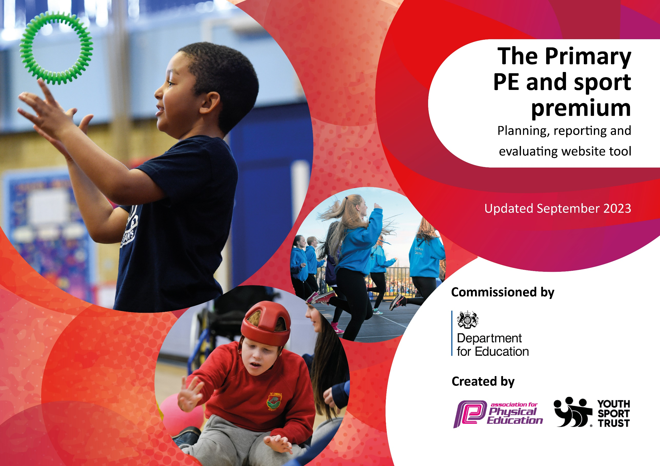

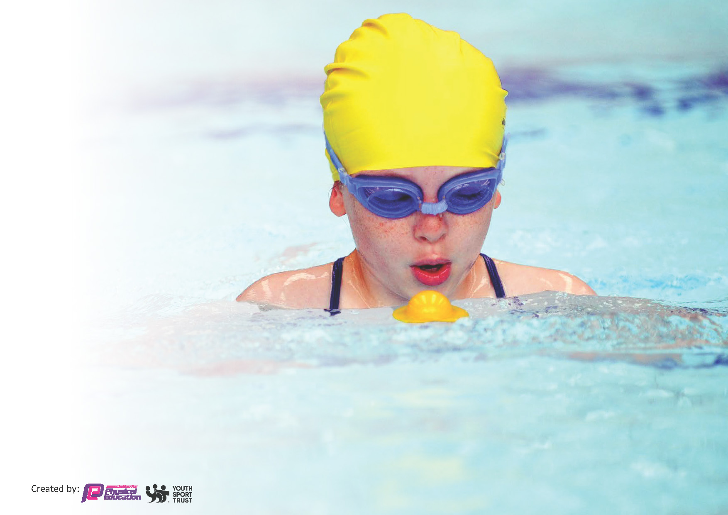
This template can be used for multiple purposes:
by:
- It enables schools to effectively plan their use of the Primary PE and sport premium
- It helps schools to meet the requirements (as set out in guidance) to publish information on their Primary PE and sport premium
- It will be an effective document to support Ofsted inspections enabling schools to evidence progress in Physical Education (PE) and evidence swimming attainment, which forms part of the PE National Curriculum. We would recommend schools consider
the Intent, Implementation and Impact of any spend, as examined within the Education Inspection Framework.

It is important that your grant is used effectively and based on school need.

Schools must use the funding to make additional and sustainable
improvements to the quality of the PE, School Sport and Physical Activity (PESSPA)
they offer. This means that you should use the Primary PE and sport premium to:

- Build capacity and capability within the school to ensure that improvements made now will benefit pupils joining the school in future years
- Develop or add to the PESSPA activities that your school already offers.

The Primary PE and sport premium should not be used to fund capital spend projects; the school’s core budget should fund these. Further detail on capital expenditure can be found in the updated Primary PE and sport premium guidance.

The Primary PE and sport premium guidance, outlines 5 key priorities that funding should be used towards. It is not
necessary that spending has to meet all the key priorities, you should select the priorities that you aim to use any funding towards.

Although completing this template is not a requirement for schools, schools are required to publish details of how they spend this funding. Schools must also outline what the impact this funding has had on pupils’ PE and sport participation and attainment and how any spending will be sustainable in the future. All funding must be spent by 31st July 2024.

The Department for Education has worked closely with the Association for Physical Education (afPE) and the Youth Sport Trust (YST) to develop this template and encourages schools to use it. This template is an effective way of meeting the reporting requirements of the Primary PE and sport premium.
Review of last year’s spend and key achievements (2022/2023) – Cromwell

We recommend you start by reflecting on the impact of current provision and reviewing your previous spend.

Activity/Action | Impact | Comments
Pupils took part in 6 intra-competitions through the academic year.  - Bouncing Statistics  - Sports Week  - Four School competitions between year groups through the year  Pupils took part in 6 inter-competitions through the academic year.  - KESSP Dodgeball  - Girls Football Festival (KESSP)  - KESSP Cricket (Y4/Y5)  - BV vs Cromwell Football Matches  - BV vs Cromwell Cricket Matches  - BV vs Cromwell Badminton matches  The school achieved the SILVER SCHOOL GAMES MARK and the Silver Award for the PE health check - Pathway to Podium  PE CPD delivered for staff:  Aspire - Tennis  Warwickshire - Cricket  AVFC - Football  KESSP – multi-skills  YOGA and Wellbeing - Yoga  KESSP - Dodgeball  Bouncing Statistics – Intra Competition CPD  Range of after school clubs delivered:  List of clubs:  Multi-skills  Football  Tennis  Basketball  Cricket  Badminton  Tag Rugby  Dodgeball  The school installed a portable swimming pool inside the school for 2 weeks in summer for KS2 pupils. | Pupils are more active throughout the year, improved resilience and developed competitive skills.  Participating in competitions helps support the personal development of pupils.  Raised the profile for PE and Sports in the school. Also helped identify actions that would develop  Improved staff confidence and knowledge in PE delivery  Pupils from KS1 and KS2 given the opportunity to participate in extra-curricular sports activities.  100% of Year 6 Pupils achieved safe-self rescue targets. | The school will continue to provide a range of intra and inter competition opportunities for pupils in KS1 and KS2.  Continue to raise the profile of PE and sports by creating a broad and balanced curriculum with CPD opportunities for staff including the use for formative assessment in PE.  The school aims to increase the number of Year 6 pupils who can swim 25m or more.

Key priorities and Planning – Cromwell: £17,800.00
This planning template will allow schools to accurately plan their spending (2023-24)

Action – what are you planning to do | Who does this action impact? | Key indicator to meet | Impacts and how sustainability will be achieved? | Cost linked to the action
Create opportunities for 30 minutes of physical activity a day in school  Order sports equipment for whole school for PE lessons and extra-curricular provision  Work with King Edwards Schools Sports Partnership (KESSP) and other agencies to create CPD opportunities for staff to work with specialist coaches. Pupils access high quality PE lessons and extra-curricular provision.  Promote benefits of sports and physical activity on mental, physical and emotional well-being. Staff CPD is on going  Subscribe to the PE HUB which provides staff with the detailed lessons that encourage skill progression  Staff CPD with specialist coaches (Cricket, Gymnastics, Dodgeball and Basketball) through team teaching  AVFC multi-skills CPD and ASC- Autumn term  Warwickshire cricket CPD and ASC -Autumn and Summer term  School staff aware of purpose of Sports premium and uses and communication from PE Lead about CPD and events (PE display board)  Conduct regular PE learning walks and provide feedback to staff  Staff training for formative assessment in PE- All teachers  Termly yoga/well-being sessions delivered by teachers. CPD given in previous year  Team building days KS1 and KS2  Ackers Adventure and Orbis Outdoor Adventures  Additional achievements:  Develop the use of personal best challenges  Develop intra-competition and inter competition  Intra competition CPD for staff and activities for pupils- Y1-6  Set aside transport costs for participation in sports competitions at other venues | Teachers, Teaching Assistants, Pupils and Lunch time supervisors and Sports coaches  Teachers and pupils  Teachers, Teaching Assistants and Pupils  Teachers, Teaching Assistants, Pupils and Sports coaches  Whole School community  Teachers and pupils  Pupils, Teachers and Teaching Assistants.  Sports Coaches, Teachers and pupils | Key Indicator 2:  The engagement of all pupils in regular physical activity – Chief Medical Officers’ guidelines recommend that primary school pupils undertake at least 30 minutes of physical activity a day in school  Key Indicator 1:  Increase confidence, knowledge and skills of all staff in teaching PE and sport  Key Indicator 3  The profile of PE and sport is raised across the school as a tool for whole school improvement.  Key Indicator 4  Broader experience of a range of sports and physical activities offered to all pupils  Key Indicator 5:  Increased participation in competitive sport | Children across the school more active and have access to a range of equipment (active play equipment, scooters, football, basketball, table tennis)  -Monitor physical activity levels and identify ways to increase physical activity throughout the school day.  All teachers have access to quality planning and CPD which helps them to confidently teach PE across a range of sports.  -Continue to deliver more CPD on effective assessment.  SMSC - Children learn to respect and work with each other, exercise self-discipline and act in a safe and sensible manner.  Pupils have access to a range of extra-curricular sports which is beneficial for pupils who cannot access other facilities due to financial constraints.  Increased staff knowledge and understanding and assessment  (Learning walks and feedback given)  -Continue learning walks to monitor quality of PE lessons  PE, physical activity and school sport have a high profile and are celebrated across the life of the school  Certificates/medals/prizes presented in assemblies.  -Continue to celebrate sports participation at a whole school level  Pupils experience a broad range of activities and experiences  -Continue to offer a broad and balanced curriculum, including a range of extra-curricular activities.  Inter and intra competitions have raised the profile of competitive sport within school.  Positive impact on the personal development (physical skills, thinking skills, social skills and personal skills).  -Continue to use pupil voice questionnaires to inform curriculum planning and competitions. | Aspire half termly- Lunch club, After school club and CPD- £2000.00  Lunchtime sports coach- £2680.00  PE equipment- £700.00  Aspire half termly After school sports club- £774.00.  Positive PE- Gymnastics CPD and ASC- £1275.00  AVCF Multi-skills- CPD and ASC- £700  KESSP- CPD, ASC and Competitions- £3950.00  Aspire Dance- CPD £425.00  Warwickshire Cricket CPD and ASC- £760.00  PE Hub Subscription- £245  Ackers Adventure Team building days KS2 -£3540. 00  Orbis Outdoor Adventure Team building days KS1- £550.00  (KESSP partnership cost)  Transport- £200.00

Key achievements 2023-2024 – Cromwell
This template will be completed at the end of the academic year and will showcase the key achievements schools have made with their Primary PE and sport premium spending.

Activity/Action | Impact | Comments
Team Building days for KS1 and KS2  CPD provision for teachers through team  teaching.  Formative assessment training for teachers  Pupil participation in after school clubs (ASC)  Pupil best challenges for KS2  Intra and Inter competition  Additional lunchtime sports activities run for pupils to take part in, towards their daily 30 minutes.  Play leader training given to Year 5 and Year pupils.  The school achieved Gold in the Pathway to Podium in recognition of their commitment to physical education, school sport and physical activity. | Pupils in KS1 experienced a range of physical activities to support their teamwork skills.  Pupils in KS2 experienced, canoeing, dry slope skiing and team building games at Ackers adventure.  Teachers developed their confidence in teaching PE and organising PE lessons with the help of specialist sports coaches.  Teachers have improved their knowledge of on- going assessment in PE and an improved understanding of physical literacy  Greater participation of girls and SEND in after school clubs and lunchtime sports.  Pupils have a better understanding of working on their skills and how to improve their performance.  Pupil have taken part in competitions against their peers from their class or school and competed against pupils from other schools.  Pupils participated in lunchtime football and multi-skills activities.  Play leaders supported the delivery of physical activities during lunchtimes.  The school was able to identify strengths and areas for improvement which it can for the future. | Team building help to support the personal development of pupils and encourage help pupils to see the vales of the school games in action.  Teachers have been given CPD in a range of sports through team teaching, they have developed new skills in delivering PE.  The use of formative assessment has helped to reduce teacher workload and give staff a better understanding of how immediate feedback for pupils can help them.  The school has encouraged more participation for target groups.  Pupils are able to set targets on how to improve on their previous performance, this helps pupils in other sports that they take part in.  Participating in inter and intra competitions helps with the personal development of pupils and some pupils also join local clubs to take part in sports.  The school will continue to deliver additional sports activities at lunchtimes which helps to towards the daily 30 minutes.  The school has been able to work on developing pupil leadership as part of the personal development focus.  The school will continue to improve the provision of physical education, sports and physical activity to support the health and well-being of our pupils.

Swimming Data – Cromwell
Meeting National Curriculum requirements for swimming and water safety.
Priority should always be given to ensuring that pupils can perform safe self-rescue even if they do not fully meet the first two requirements of the National Curriculum programme of study

Question | Stats: | Further context  Relative to local challenges
What percentage of your current Year 6 cohort can swim competently, confidently and proficiently over a distance of at least 25 metres? | 26% | The number of year 6 swimmers who can swim 25 meters or more without any support is lower than expected this year.  This may be due to fewer hours spent swimming because the swimming booking coincided with SATs week.  All future bookings will be made after Year 6 SATs.
What percentage of your current Year 6 cohort can use a range of strokes effectively [for example, front crawl, backstroke, and breaststroke]? | 100% | Pupils showed increased confidence in the pool and demonstrated effective use of a range of strokes during their water confidence lessons

What percentage of your current Year 6 cohort are able to perform safe self-rescue in different water-based situations? | 100% | Pupils worked on practical safe-self rescue activities in the pool, this helped to achieve good outcomes for all pupils in relation to safe-self rescue.
If your schools swimming data is below national expectation, you can choose to use the Primary PE and sport premium to provide additional top-up sessions for those pupils that did not meet National Curriculum  requirements after the completion of core lessons. Have you done this? | No | Due to issues with the availability of swimming bookings the school had to book swimming sessions over the Year 6 SATs period. This impacted the number of swimming hours that Year 6 pupils.  In future the school will ensure that booking are made outside of this time to allow for additional swimming lessons for Year 6.
Have you provided CPD to improve the knowledge and confidence of staff to be able to teach swimming and water safety? | No | The school is presently using external qualified swimming instructors to deliver swimming and safe self-rescue, in the pool.

Signed off by:

Head Teacher: | Rubina Darr
Subject Leader or the individual responsible for the Primary PE and sport premium: | Saiqa Bi
Governor: | Nasir Uddin (Trustee) 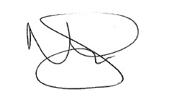
Date: | 23.07.24

